**PRACTICAL No.6**

**AIM:** **Write a Program to find the average of given four numbers.**

**STEPS:**

#Write a Program to find the average of given four numbers.

num1=int(input("Enter first number: "))

num2=int(input("Enter second number: "))

num3=int(input("Enter third number: "))

num4=int(input("Enter fourth number: "))

a=(num1+num2+num3+num4)/4

print(a)

____________________________________________________________________________________________________________________________________________________________________________________________________________________________________________________________________________________________________________________________________________________________________________________________________________________________________________________________________________________________________________________________________________________________________________________________________________________________________________________________________________________________________________________________________________________________________________________________________________________________________________________________________________________________________________________________________________________________________________________________

**SCREENSHOT:**

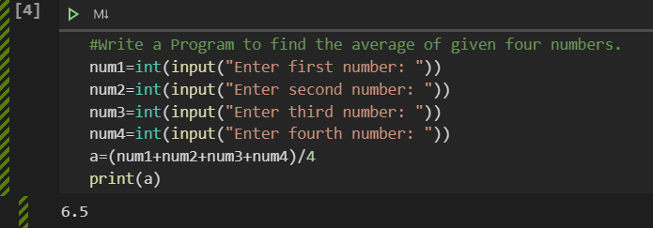

**Date:**